SECURITY MODELS
Security Model: A conceptual framework that defines the security requirements and access control mechanisms for a system.

Key Terms
- Subject: An active entity (e.g., user or process) that requests access to resources.
- Object: A passive entity (e.g., data or files) that is being accessed or manipulated.
- Access Control: Mechanisms that restrict access to resources based on predefined security policies.
- Integrity: Assurance that data is accurate and unaltered.
- Confidentiality: Assurance that information is not disclosed to unauthorized individuals.
- Mandatory Access Control (MAC): A model where access rights are regulated by a central authority based on multiple levels of security.

Objectives and Application of Security Models in Organizations
Security models provide a structured approach to protect sensitive data and ensure compliance with regulatory requirements. By implementing these models, organizations can effectively manage access control, protect against unauthorized data manipulation, and maintain the integrity and confidentiality of their information.

1. Bell-LaPadula Model

Overview
The Bell-LaPadula (BLP) Model focuses on maintaining the confidentiality of information within a multi-level security environment. It operates under the Mandatory Access Control (MAC) framework, where security classifications are assigned to both subjects and objects. The hierarchy often includes classifications such as Top Secret, Secret, Confidential, and Unclassified.

The set of access rights given to a subject are the following:
- Read-Only: The subject can only read the object.
- Append : The subject can only write to the object but it cannot read.
- Execute : The subject can execute the object but can neither read nor write.
- Read-Write: The subject has both read and write permissions to the object.
Control Attribute: This is an attribute given to the subject that creates an object. Due to this, the creator of an object can pass any of the above four access rights of that object to any subject. However, it cannot pass the control attribute itself. The creator of an object is also known as the controller of that object.

Properties of Bell-LaPadula Model

1. The Simple Security Property (No Read Up)
- The Simple Security Property states that, “A subject at a given security level may not read an object at a higher security level”.

2. The Star Property (No Write Down)
- The Star Property states that, “A subject at a given security level may not write to any object at a lower security level”.

3. The Strong Star Property
- The Strong Star Property states that, “A subject can perform read & write capabilities only on those functions present at the same security level”. ( i.e A subject in one classification level cannot read or write to any other classification level)
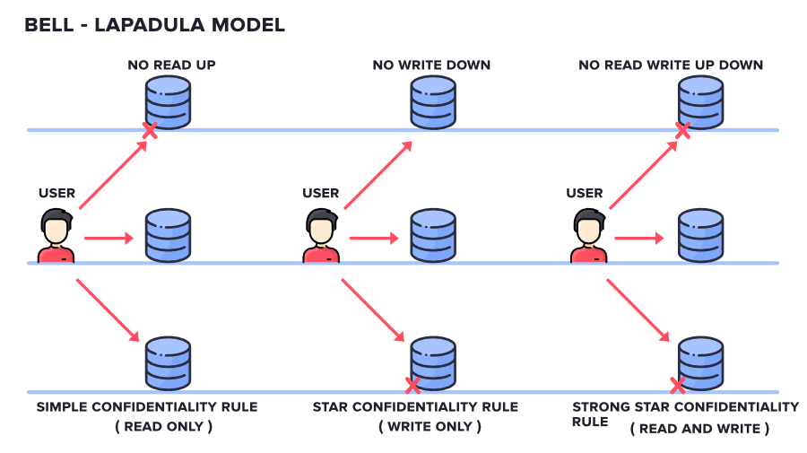

Application
Scenario: A government agency handling classified information implements the BLP Model. Employees are assigned access based on their security clearance. For example, an analyst with "Confidential" clearance can read "Confidential" and "Unclassified" documents but cannot access "Secret" or "Top Secret" files. This mechanism ensures that sensitive information does not get disclosed to unauthorized personnel.

Strengths
- Prevents unauthorized access to classified information.
- Enforces strict control over data flow, minimizing the risk of leaks.

Limitations
- Inflexible regarding changing security levels, making it difficult to adapt to evolving threats.
- Does not address data integrity, leaving the system vulnerable to unauthorized modifications.

2. Biba Model

Overview

This Model was invented by Scientist Kenneth .J. Biba. Thus this model is called Biba Model. This is used to maintain the Integrity of Security. Here, the classification of Subjects(Users) and Objects(Files) are organized in a non-discretionary fashion, with respect to different layers of secrecy. This works the exact reverse of the Bell-LaPadula Model.
It has mainly 3 Rules:
- SIMPLE INTEGRITY RULE: Simple Integrity Rule states that the Subject can only Read the files on the Same Layer of Secrecy and the Upper Layer of Secrecy but not the Lower Layer of Secrecy, due to which we call this rule as NO READ DOWN
- STAR INTEGRITY RULE: Star Integrity Rule states that the Subject can only Write the files on the Same Layer of Secrecy and the Lower Layer of Secrecy but not the Upper Layer of Secrecy, due to which we call this rule as NO WRITE-UP
- STRONG STAR INTEGRITY RULE

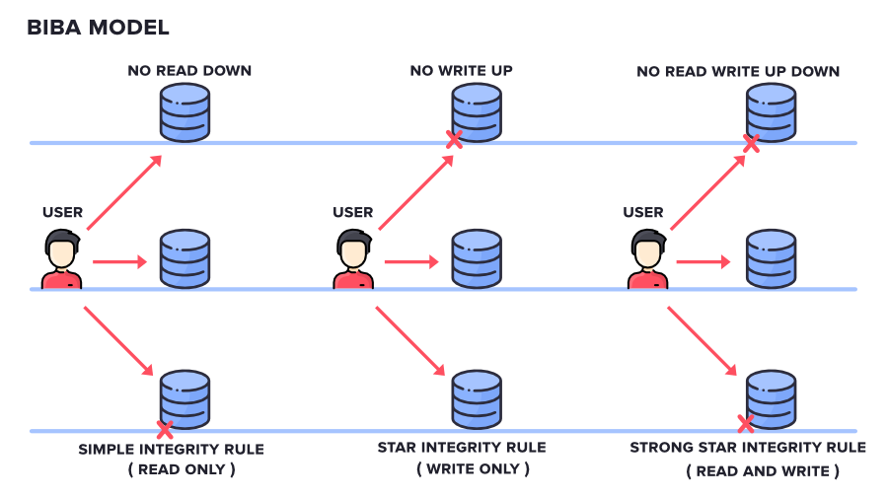

Application
Scenario: A financial institution employs the Biba Model to safeguard transaction data. Employees are assigned integrity levels based on their roles. For example, a teller can read and write to "Low" integrity data but cannot access "High" integrity data, such as account reconciliation reports. This ensures that only authorized personnel can modify critical financial data.

Strengths
- Protects against data corruption by restricting access based on integrity levels.
- Facilitates a clear hierarchy of data integrity, ensuring reliable information.

Limitations
- Focuses solely on integrity, neglecting the aspect of confidentiality.
- Complexity in implementing integrity levels across diverse systems.

3. Clark-Wilson Model

Overview
The Clark-Wilson Model enforces integrity through well-formed transactions and a strict separation of duties. It categorizes data into constrained and unconstrained data items, requiring all transactions to be conducted through defined transformation procedures.
- SUBJECT: It is any user who is requesting for Data Items.
- CONSTRAINED DATA ITEMS: It cannot be accessed directly by the Subject. These need to be accessed via Clarke Wilson Security Model
- UNCONSTRAINED DATA ITEMS: It can be accessed directly by the Subject.

Key Components
- Constrained Data Items (CDIs): Sensitive data requiring strict access controls.
- Transformation Procedures (TPs): Defined operations that manipulate data, ensuring proper access controls.
- Integrity Verification Procedures (IVPs): Audit mechanisms that ensure transactions maintain internal and external consistency.
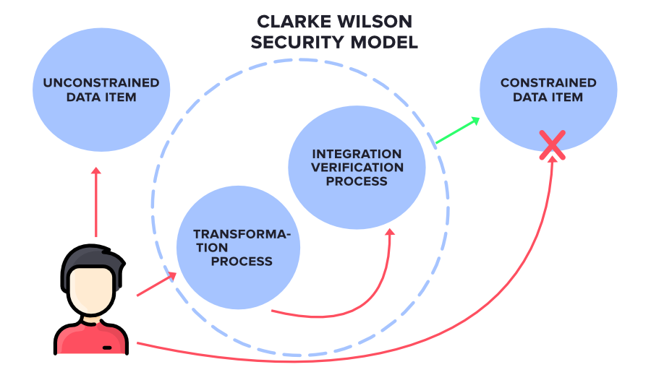

Application
Scenario: An online banking system adopts the Clark-Wilson Model. Customers access their accounts through a secure web interface, which serves as a transformation procedure. Any transaction, such as funds transfer, must be validated by an IVP. This prevents unauthorized users from directly manipulating sensitive data.

Strengths
- Strong emphasis on maintaining data integrity through structured processes.
- Enables separation of duties, thereby reducing the risk of fraud and errors.

Limitations
- More complex to implement than simpler models due to the need for well-defined procedures.
- Requires ongoing monitoring and auditing to maintain integrity.

4. Chinese Wall Security Policy

Overview
The Chinese Wall Security Policy addresses conflicts of interest by restricting access based on a user’s history of access to data from competing entities. This model aims to protect sensitive information while maintaining client trust.

Key Components
- Conflict of Interest Classes: Groups of companies that compete and should not have their data compared or accessed by the same individual.
- Access History: Determines a user's eligibility to access specific data sets based on previous access.

Application
Scenario: A consultancy firm employs the Chinese Wall Policy to manage access to client data. If an analyst accesses confidential information from Company A, they are restricted from accessing Company B’s data, which belongs to a competing firm. This policy mitigates the risk of inadvertent disclosure and preserves client confidentiality.

Strengths
- Effectively manages conflict of interest situations, particularly in competitive environments.
- Protects sensitive data while allowing necessary access for business operations.

Limitations
- Complex to enforce due to reliance on detailed access history.
- Can hinder information sharing and collaboration within organizations, as it restricts access based on past interactions.

Comparative Analysis of Security Models
Model | Focus | Key Properties | Strengths | Limitations
Bell-LaPadula | Confidentiality | No Read Up, No Write Down | Strong confidentiality, prevents unauthorized access | Ignores integrity
Biba | Integrity | No Read Down, No Write Up | Protects data integrity, clear hierarchy | Ignores confidentiality
Clark-Wilson | Integrity | Well-formed transactions | Separation of duties, structured processes | Complex implementation
Chinese Wall | Conflict of Interest | Access history | Effectively manages conflicts | Complex enforcement

Case Study Title: Security Models in Action at the National Intelligence and Research Agency (NIRA)

Background
NIRA is a high-security government agency with two primary divisions:
- Intelligence Division – tasked with handling classified surveillance data.
- Research and Development Division – responsible for scientific and technological research.
To enforce confidentiality and integrity, NIRA uses:
- The Bell-LaPadula (BLP) model in the Intelligence Division.
- The Biba model in the Research and Development Division.

Scenario Overview
- A junior intelligence analyst with "Confidential" clearance tries to access a "Top Secret" surveillance file.
- A junior researcher with a lower integrity level attempts to modify a senior scientist's high-integrity scientific report.

Case Study Questions

Main Questions:
a) Explain how the Bell-LaPadula Model applies to the first scenario.
- Identify which security property is being enforced and why.
- Relate the analyst's clearance level to the file’s classification.
b) Explain how the Biba Model applies to the second scenario.
- Identify which integrity rule is being applied.
- Discuss its importance in scientific research integrity.
c) Discuss two advantages of combining both Bell-LaPadula and Biba models in a high-security organization like NIRA.
- Support your answer with examples from both divisions.

Additional Questions for Deeper Analysis:
d) What potential risks could arise if NIRA only implemented the Bell-LaPadula model and not the Biba model?
e) Suggest and justify the use of a real-world security mechanism or technology (e.g., access control system, mandatory access control) that could help enforce these models effectively in NIRA.
f) Evaluate the limitations of the Bell-LaPadula and Biba models in handling modern threats such as insider threats or data exfiltration.
g) How could the principle of least privilege complement the enforcement of both models within NIRA?
h) Propose a training strategy for junior staff to help them understand and comply with these security models.

Instructions for Submission
- Work in groups.
- Submit by AFTER 2 WEEKS
- Format: Soft copy to josephmbugua@ygau.ac.ke
- Include an introduction, clear responses to each question, and references where applicable.

